Friends of the Montclair RR Trail

Join us, visit our website to see
how you can get involved.

Web site: www.MontclairRRtrail.org
Email: MontclairRRTrail@gmail.com



ver 2

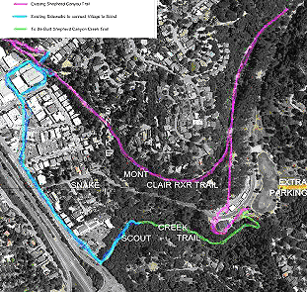

Montclair Railroad Trail Access:

There are several ways to approach the trail, here’s two easy access points:

From Montclair Village:
Behind McCaulou’s Parking lot at 6211 Medau Pl. Follow the gentle grade up to the trail.

Parking: Montclair Parking Garage, LaSalle Ave.

From Shepherd Canyon:
Bishops Court, walk to the end of the street and follow the tree-lined trail.

Parking: limited street parking on Paso Robles Dr
at Bishops Court.

Web site for more information and maps.
www.MontclairRRTrail.org

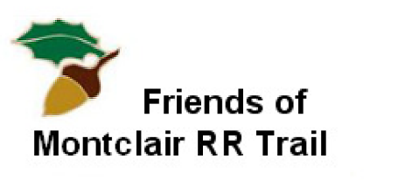

The Montclair Railroad Trail, stretching through Shepherd Canyon, was built on the rail bed of the historic Sacramento Northern Railway. From 1912 to 1957 passenger and freight trains ran between Oakland and Chico.

In the 1970s community action stopped the construction of proposed highway 77, which would have replaced the rail bed with a multi-lane freeway. The trail was created instead.

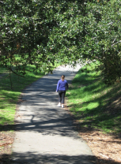

Today, the Montclair RR Trail provides a beautiful natural setting for hiking, bicycling and dog walking with access to Montclair Village, and the residential neighborhoods of Shepherd Canyon and Montclair.

Friends of

Montclair RR Trail
www.MontclairRRtrail.org

The Friends of Montclair RR Trail was formed to maintain, preserve and enhance the wild and natural character of the Montclair Railroad Trail. We are a community-based group of trail users, neighbors and supporters who value this unique trail and wish to create a lasting natural legacy for future generations to enjoy.

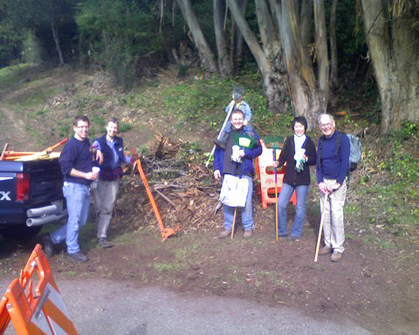

We provide an extra pair of eyes and additional hands when needed, augmenting Parks and Recreation resources to keep our Trail clean, safe and natural for all who use it.

We are a dues-based organization for households and other community supporters. Dues support a modest organizational infrastructure of volunteers

Why Join?

Membership allows a strong voice and support for targeted programs:

Be a voice for the trail on behalf of users and as
an advocate with the City of Oakland.

Participate in development of educational programs to teach our children to become future stewards.

Contribute ideas, and labor to the continuing naturalization of the trail, through eradication of invasive species and plantings of native plants.

Suggest solutions for improvements such as signage, drainage, clean-up activities and graffiti removal.

Alert the community and City to safety issues.

Become part of a growing and thriving network
of community support activities in Montclair.

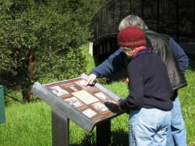

Membership Form

Annual Dues: Household: $25
Business/Organization: $50

Online: www.MontclairRRtrail.org

By Mail: Checks payable to: FOMRRT
Mail to: FOMRRT, 5837 Snake Rd
Oakland CA 94611

Name:

Email:

Phone:

Name:

Email:

Phone:

___Business?
___Household?

Your information will not be shared with other groups, or used for any purpose other than FOMRRT business.

